Step1: Click on the 64 bit git for windows setup

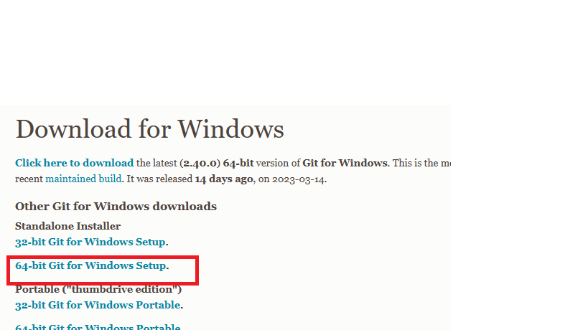

Step2: Select ‘Yes’ on the next page when you double click on the downloaded file

Step3: Click ‘next’ on the following 3 pages

Step4: Select the highlighted options and click ‘install’

